AWARE’s top five home-schooling tips
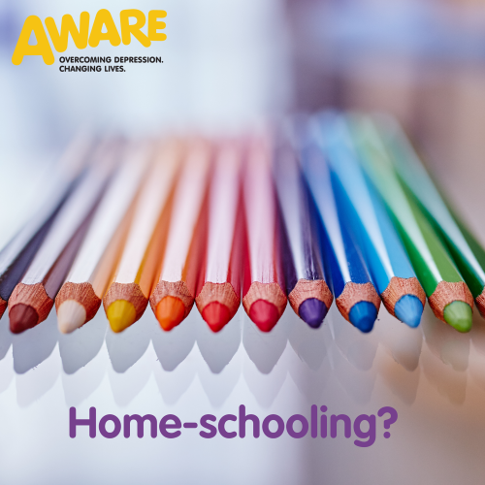

Is this your first week home-schooling the little ones? We know this can cause feelings of uncertainty and may put a strain on your mental health, so we want to give you our top five tips on home-schooling...
1. Don’t Stress
It’s easier said than done but this is so important, especially, in these uncertain times. Don’t feel you have to take on the teacher’s role as this will cause unnecessary stress. Focus on activities that will help stimulate the brain but also enable you and your kids to have fun in the process even if that means going back to basics; reading, puzzles and arts and crafts.
Have you got kids aged 4-12? Carol Vorderman has just released her maths support platform for free to help support families during these difficult times, click here to sign up now.
TTS group have some great downloadable activity packs you can work through, click here .
The Education and Training Inspectorate also have some great resources for pre and post-primary, click here.
2. Establish a routine
Studies show young people work better when they are in a routine. Why not get create a simple timetable for the week?
Take regular breaks and make time for exercise even from the comfort of your living room, there are lots of online workouts available and Joe Wicks has launched a mission to become the nations PE teacher by doing live PE classes on YouTube at 9am every Monday – Friday.
A great way to start the day and help your kids get focused. Click here to check it out.
3. Eat a healthy balanced diet
A balanced diet is essential for healthy brain function so try to include a variety of healthy foods in your family’s diet as much as possible. This includes fruit and veg, lots of water and avoiding excess sugar. You could get the kids involved by making a new recipe or baking some healthy treats!
Need some inspiration? BBC GoodFood has got you covered, click here.
4. Get creative
We have now been given the gift of time, so this is a great opportunity for you and your little ones to learn a new skill and get creative. Create a poster about your favourite book, write a poem or use those extra loo roll tubes to make an art masterpiece!
Click here to check out some cool ideas.
5. Take time to look after YOU
In order to lead by example you should take time to look after yourself. Have a look at our mental health tips on our social media pages. Make sure you lead by example by eating healthy, taking part in physical exercise and taking time to relax by doing something that makes you happy.
Remember...
“At the end of the day, remind yourself that you did the best you could today, and that is good enough.” ― Lori Deschene

